CS 3100

Hackathon 10

General Directions: Please answer each question in a Word and submit it for grading. Each question is worth 20 points.

In this exercise, you will apply the concepts learned in this course to put a data table in third normal form and to create an entity-relationship diagram (ERD).

Use the data table below to answer Questions 1-4. Here are descriptions of each column in the table.

PO #: Purchase order number

PO Date: Purchase order date

Vendor: Company that Tasty Catering is making a purchase from

Vendor Contact Number: Vendor’s phone number

Ship to Address: Tasty Catering’s shipping address. Tasty Catering only has one office location: 111 Crystal Lake, Kansas City, MO 64110.

Line: Line order number

Part #: Purchased item number

Desc: Description of purchased item

Qty: Quantity of purchased item

Price: Price of purchased item (for 1 quantity)

LineTotal: Qty x Price

|  |  |  |  |  |  |  |  |  |  |  |
| --- | --- | --- | --- | --- | --- | --- | --- | --- | --- | --- |
| **PO #** | **PO Date** | **Vendor** | **Vendor Contact Number** | **Ship to Address** | **Line** | **Part Number** | **Desc** | **Qty** | **Price** | **LineTotal** |
| 1 | 4/4/2016 | Wholesale Restaurant Supply | 816-501-4044 | 111 Crystal Lake, Kansas City, MO 64110 | 1 | A11 | Festive Plate | 50 | 0.35 | 17.50 |
| 1 | 4/4/2016 | Wholesale Restaurant Supply | 816-501-4044 | 111 Crystal Lake, Kansas City, MO 64110 | 2 | A12 | Dessert Plate | 50 | 0.15 | 7.50 |
| 1 | 4/4/2016 | Wholesale Restaurant Supply | 816-501-4044 | 111 Crystal Lake, Kansas City, MO 64110 | 3 | B10 | Fork | 50 | 0.02 | 1.00 |
| 1 | 4/4/2016 | Wholesale Restaurant Supply | 816-501-4044 | 111 Crystal Lake, Kansas City, MO 64110 | 4 | B11 | Spoon | 50 | 0.02 | 1.00 |
| 1 | 4/4/2016 | Wholesale Restaurant Supply | 816-501-4044 | 111 Crystal Lake, Kansas City, MO 64110 | 5 | B12 | Knife | 50 | 0.02 | 1.00 |
| 1 | 4/4/2016 | Wholesale Restaurant Supply | 816-501-4044 | 111 Crystal Lake, Kansas City, MO 64110 | 6 | C100 | Paper Towel | 100 | 0.05 | 5.00 |
| 1 | 4/4/2016 | Wholesale Restaurant Supply | 816-501-4044 | 111 Crystal Lake, Kansas City, MO 64110 | 7 | D100 | Plastic Cup | 50 | 0.45 | 22.50 |
| 1 | 4/4/2016 | Wholesale Restaurant Supply | 816-501-4044 | 111 Crystal Lake, Kansas City, MO 64110 | 8 | D101 | Champagne Glass | 50 | 8.75 | 437.50 |
| 2 | 4/5/2016 | Sysco Kansas City Inc | 913-829-5555 | 111 Crystal Lake, Kansas City, MO 64110 | 1 | E01 | Dinner Rolls | 100 | 0.30 | 30.00 |
| 2 | 4/5/2016 | Sysco Kansas City Inc | 913-829-5555 | 111 Crystal Lake, Kansas City, MO 64110 | 2 | E02 | Whole Wheat Bread (Sliced) | 20 | 2.00 | 40.00 |
| 3 | 4/6/2016 | Sysco Kansas City Inc | 913-829-5555 | 111 Crystal Lake, Kansas City, MO 64110 | 1 | E03 | Whole Wheat Bread | 20 | 2.00 | 40.00 |
| 3 | 4/6/2016 | Sysco Kansas City Inc | 913-829-5555 | 111 Crystal Lake, Kansas City, MO 64110 | 2 | M100 | Salami (Sliced) | 5 | 10.00 | 50.00 |

1. Put the data table above in first normal form (1NF). Here are the rules of 1NF:
   * Do not put multiple items of the same type in one column (i.e. the atomicity rule)
   * Do not repeat similar data in multiple columns
   * Identify each set of related data with a primary key

Hint: The 1NF output should be one table.

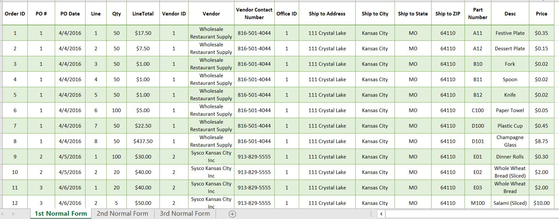

1. Put the data table above in second normal form (2NF). Here are the rules for 2NF:
   * Requirements of 1NF are met.
   * Decompose the data to remove functional dependencies

Hint: The 2NF output should contain more than one table.

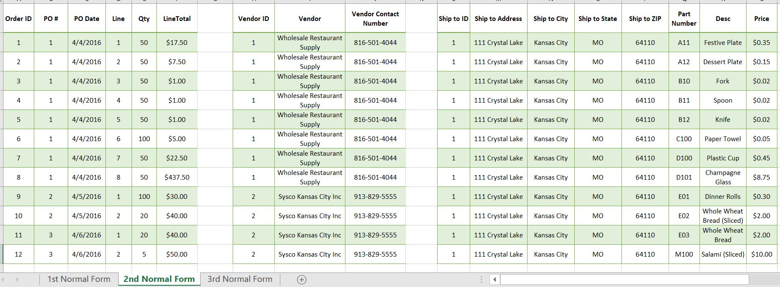

1. Put the data table above in third normal form (3NF). Here are the rules for 3NF:
   * Requirements of 2NF are met.
   * Remove transitive dependencies.

Hint: The 3NF output should contain more than one table.

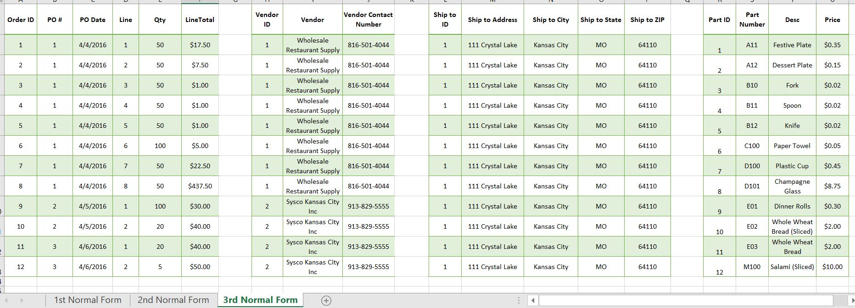

1. Create an entity-relationship diagram (ERD) to represent your data tables. You can use Crow’s foot, Universal Modeling Language (UML), or Chen’s notation to represent relationships in the ERD. I do not have a preference. Take a picture or attach the ERD for grading. You can get a free single user account at LucidChart to make an ERD: <https://www.lucidchart.com/pages/how-to-draw-ERD>. LucidChart allows users to print an ERD as a PDF file.

